**GITHUB:**

Git - the simple guide: <http://rogerdudler.github.io/git-guide/>

How to Use Git and GitHub(Free Course): <https://in.udacity.com/course/how-to-use-git-and-github--ud775>

**ANDROID STUDIO**

Plugins-

1. Steps to instal plugins in Android studio:
   1. Run Android Studio.
   2. Goto File > Settings.
   3. In the Settings window goto plugins then click browse repositories which is located at the bottom of settings window.
   4. Now search for that plugin that you wish to install.
   5. Click Install.
   6. Restart Android Studio.
2. Useful Plugins:
   1. ADB Idea
   2. Key Promoter
   3. Android Material Design Icon Generator
   4. .ignore

**BLOGS TO READ:**

1. <http://blog.teamtreehouse.com/the-beginners-guide-to-android>
2. <http://www.anddev.org/>
3. <http://www.vogella.com/tutorials/android.html>
4. <https://blog.stylingandroid.com/#>
5. <https://androiduipatterns.com/>
6. <https://jeroenmols.com/blog/2018/02/22/androidstudioshortcuts/>

**ANDROID GUIDE:**

## **What is Android?**

Android is a stack of operating system, middleware and applications developed by Google that is dedicated to mobile devices. Android relies on Linux kernel 2.6 for core services. The Android platform provides API and Tools to develop applications using Java Platform. It features Dalvik Virtual Machine, SQLite, an integrated browser, application framework, as well as various media and hardware support.

## **Basic Concepts**

The following table outlines the key concepts in an Android application:

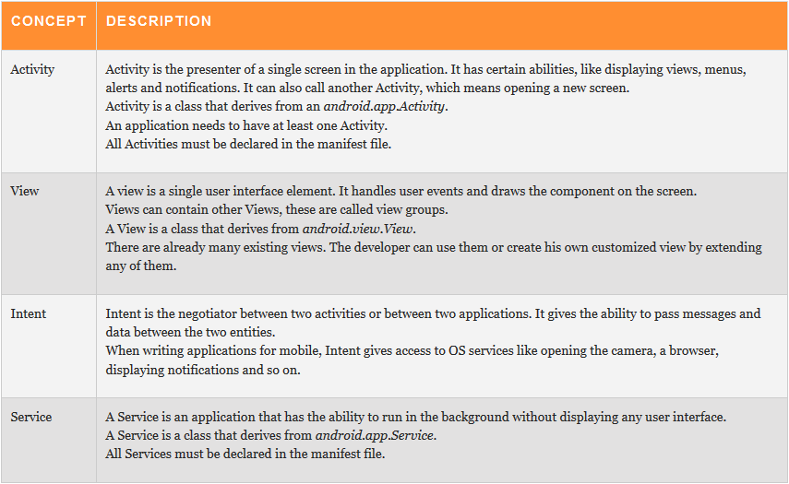

## **An Android Project Structure**

**Manifest file:** AndroidManifest.xml defines the Android application. It contains the attributes, activities, versions, permissions, and other parameters of the application.

**'src' folder:** As with any Java project, this folder holds all Java source code and packages.

**'res' folder:** Contains local resources for the application:

1. 'drawable' – image folders according to resolutions. By default there are 3 folders for 3 basic resolutions.
2. 'layout' – xml files which represent display layout. By default a main.xml is created.
3. 'values' – xml files which define global constants, strings, styles or colors.

**SDK jar:** Contains the android.jar which is different across versions of the SDK.

**'gen' folder:** This folder contains the R class which is automatically generated by the Eclipse plugin and gives access to the project resources.

**'assets' folder:** This folder holds other raw resource files such as movie or sound files. By default, this folder is not created. These resources will not be modified.

### **Creating Android Virtual Device (AVD):** Here's a link that will help you create an AVD

### [**https://www.youtube.com/watch?v=Wx4KWPZhSHc**](https://www.youtube.com/watch?v=Wx4KWPZhSHc)

### **Signing and Generating jars:** Android applications are zipped to jar files. The only difference is that Android jar files have a special extension - .apk. All application jars have to be signed before they are installed.

For more instructions read<http://developer.android.com/guide/publishing/app-signing.html>